

International Journal of Serious Games

ISSN: 2384-8766
https://journal.seriousgamessociety.org/

Article
Escape Racism: Using the EscapED Methodology to Inform the Design of Educational Escape Rooms
Mark Lewis¹, Petros Lameras¹, Sylvester Arnab¹.

¹Centre for Postdigital Cultures, Coventry University, Coventry, United Kingdom
{Mark Lewis} ac6055@coventry.ac.uk

Keywords:

Serious Games
Game-based Learning
Escape Room
Modern Slavery
Game Design
escapED

Received: November 2024
Accepted: May 2025
Published: May 2025
DOI: 10.17083/ijsg.v12i2.905
Abstract
Over the last decade, escape rooms have been increasingly recognized for their educational value, leading to the publication of several theoretical models to facilitate their design. The earliest of these is widely perceived as the escapED framework. In this paper, we present Escape Racism, which involved the creation of 10 educational escape rooms using the escapED methodology to inform their design. We present a case study outlining the design-based development process undertaken using the escapED methodology. We then reflect upon this process, discussing modifications that were made within the framework during development. Data collected from 215 educators, youth workers, and young people, who evaluated the escape rooms, is then analysed and presented. The findings revealed that the escapED framework was both usable and effective in their creation, however, the development process undertaken by the authors was more agile and iterative than originally described. Additionally, a mixed methods approach was employed to evaluate the impact of escapED’s usage within Escape Racism. The findings from the study demonstrated that the knowledge gained from playing escape rooms created using escapED was increased and also delivered an emotional response amongst participants.

Introduction
Escape rooms are a form of team-based entertainment within which players attempt to uncover clues, solve puzzles, and complete challenges that allow them to escape from a room, or meet other specific goals within a specific time limit [1]. According to Nicholson [1], escape rooms first appeared as a commercial experience in 2007, in Japan. Since their inception, they have become a global phenomenon, and their influence has grown substantially. In 2019, Kroski [2] estimated that there were approximately 7,200 escape rooms worldwide. However, this figure is contested by alternative research that places their number at somewhere between 50-60,000 [3]. Smaller and more portable evolutions of the escape room paradigm have also appeared, the most notable of these becoming known as breakout boxes or escape-room-in-a-box (e.g. Veldkamp et al., 2020) [4]. These are small self-contained escape rooms consisting of small artefacts and paper-based puzzles that fit inside a box. Other forms of escape rooms include escape books, where readers solve a series of puzzles to reach the story’s conclusion, and puzzle hunts, where teams or individuals solve puzzles for a final reward either online or in person.
Over the last decade, the educational strengths of escape rooms have increased significantly. This has been partly driven by research into the format, which has covered investigations into the generation of theoretical models and methodologies for the creation of Educational Escape Rooms (EERs) such as escapED [5], the Serious Escape Game Model (SEGAM) [6], and the Star Model [7], the use of EERs as a tool for promoting Game-Based Learning (GBL), and investigations of the educational benefits that EERs can provide. An EER is perceived as “an instructional method requiring learners to participate in collaborative playful activities explicitly designed for domain knowledge acquisition and as a skill development process for accomplishing a specific goal (e.g., escape from a physical room or break into a box) by solving puzzles linked to unambiguous learning objectives in a limited amount of time” [7]. The complexity of EERs, and the puzzles that combine to form them, require players to use a range of skills when attempting to solve them. This includes skills that are considered key for both work and life in general, such as critical thinking, lateral thinking, communications, attention to detail, leadership, and teamwork [7][8]. The rich-enabled sensory environment and fun experience provided by EERs make them capable of increasing player engagement with subject matter, and enabling a sense of flow, a state which has long been recognized as being optimal for learning experiences [7][9].
EscapED, developed at Coventry University, discerned a theoretical methodology for the creation of escape rooms with an educational theme [11], and other interactive game solutions for learning and behavioral change [5]. The escapED framework consists of six stages: Participants, Objectives, Theme, Puzzles, Equipment, and Evaluation. These stages are further broken down into specific areas that are required to create an escape room for use within an educational environment [5]. Since it was first published in 2017, the escapED framework has helped to inform the development of other EERs and research into new, alternative methodologies for their creation [11]. However, much of the research that cites escapED as an influencing factor also notes that its efficacy and quality have yet to be validated in terms of its usability and usefulness [11].
In this paper, we aim to assess the viability of using the escapED methodology to inform the design of EERs and whether the expected educational outcomes are achieved. This is performed through its implementation using a design-based methodology within the Escape Racism project. Participating designers within the project were introduced to the escapED framework and subsequently tasked with creating their own EERs. The resulting 10 EERs were built and tested by n=215 educators, youth workers, and students to assess their quality and effectiveness as educational tools. In turn, the processes undertaken bring us closer to understanding the efficacy and usability of the escapED methodology.
The paper commences by discussing the escapED framework through an examination of alternative methodologies that have been researched since its inception. The methods used to inform, create, test, and evaluate EERs for this study will be analysed and synthesized. Through this process, we aim to address three research questions: (1) Is the escapED framework a viable methodology for creating educational escape rooms? (2) Do educational escape rooms created using escapED provide educational benefits? (3) Can the escapED framework be adapted to reflect the actual design process? Finally, the findings obtained during the testing sessions will be presented and discussed.

Background
The escapED framework is widely considered the earliest attempt at generating a conceptual methodology for the design and development of EERs and interactive game solutions for learning, and behavioral change in higher educational settings [7][11]. Influenced by work previously conducted by Arnab & Clarke [12] within the field of GBL, and Nicholson’s whitepaper on escape room facilities [1], escapED was originally envisioned as a small project within Coventry University’s Game Changers initiative. It is primarily targeted at educators who work within the realms of higher or further educational environments [5]. Utilising the pedagogical construct of ‘learning by designing’, the framework combines elements of game design thinking and experience of commercial escape rooms, adapting and merging them to incorporate educational paradigms, learning objectives, and metrics for behavioral change [5].
Since its publication in 2017, in either its original or modified form, escapED has helped drive and inform the creation of several EERs [13][14][15]. It has also influenced the creation of alternative methodologies aimed at the development of EERs such as the Star Model [7], and the Room2Educ8 framework [11]. Other non-related frameworks have also since been created, notably SEGAM [6], the five-step cyclic design process by Eukel & Morell [16], and the Context, Objectives, Materials, Execution, and Team Dynamics (COMET) framework [17].
The Star model was created as part of a study for the School Break project and was considered to be ‘an elaboration and extension of escapED’ [7] by its authors. The core of the model uses five game design elements (narrative, game-flow, puzzles, equipment, and learning) which represent the points of a star. Around the core are placed four additional dimensions (players, constraints, evaluation, and debriefing) which the authors suggested influenced all of the core design elements. To validate the Star model, fifty teachers completed a course in EER design prior to being surveyed. The authors reported that overall, they had received overall positive results [7].
The SEGAM framework utilizes aspects of the DISC (Domain, Interaction, Scenario, Context) model proposed by Vermeulan et al. in 2017 [18] to break the EER up into levels, each of which represents a stage of the game. Each level consists of a riddle that correlates to one or multiple educational objectives (diagnostic, formative, summative or discovery of notion) [18], and each of these riddles can be solved separately whilst retaining a link to the EERs overarching narrative. The framework also provides information on how to approach various aspects of creating an EER such as constraints, pedagogy, parameterisation, and background [18].
Room2educ8 [11] is another EER framework influenced by both escapED and game design thinking. It consists of nine stages for creators to work their way through as they gradually construct an EER. These are 1) emphasize and observe the customer, 2) define constructs such as learning objectives, game type, and group size, 3) Contextualize the EER by selecting its theme, setting and narrative, 4) design the EER, 5) determine how to brief participants, 6) determine how to debrief participants, 7) prototype and playtest the EER, 8) Document the EER by creating game design documents, facilitator guides, and manuals, 9) evaluate the EER by observing, interviewing, and surveying its users. When validating Room2educ8, over the course of four years n=104 MSc students were tasked with collaboratively designing, developing, facilitating, presenting, and documenting an EER experience using the Room2educ8 model as part of their coursework. The validity of Room2educ8 was assessed using a mixed-methods quantitative and qualitative study, which indicated that the framework was highly detailed with clear and understandable steps that can be used to develop a range of EERs and a variety of topics [11].
Eukel and Morell [16] presented a cyclic design process. This consisted of five steps; design, pilot, evaluate, redesign, re-evaluate. Although simplistic in nature, Eukel and Morell’s process emphasizes the importance of an iterative approach to the design of EERs.
The COMET framework is a step-by-step approach for designing EERs that was developed to facilitate the creation of EERs for medical professionals who require understanding of specific medical knowledge, attitudes, skills, and safety requirements [17]. It consists of five stages: Context, Objectives, Materials, Execution, and Team Dynamics. The framework was evaluated within a workshop consisting of 22 participants, the majority of which had no prior knowledge of creating EERs. The COMET framework was found to be beneficial for all participants, regardless of knowledge level, with the majority indicating that they would plan to utilize the framework to design EERs in the future [17].
Each of the methodologies described are similar in form. All, apart from the SEGAM framework [18], employ a series of defined stages that allow creators to build their experience gradually, in a participatory manner. Each of the frameworks also cover similar areas such as context, learning objectives, playtesting, creation of documents, etc. However, two-thirds of the frameworks, including escapED [12] have yet to be validated in any form.

The EscapED Framework and Case Study
The opportunity to assess how the escapED methodology could be used to create EERs was made possible through its application in the Escape Racism project. The project aimed to foster more inclusive societies by promoting human rights education through the use of educational escape rooms and related resources. These resources, which are freely available for download, are designed for youth workers and teachers to use or adapt in order to engage young people with various human rights topics.
The project commenced just as the COVID-19 pandemic began to affect Europe, making social experiments such as Escape Racism extremely difficult to facilitate. This meant that with the exception of a single face-to-face meeting in February 2020, and the later testing sessions, all project work took place online via either Microsoft Teams or Zoom. During these meetings, twelve members of the Escape Racism team were introduced to the escapED framework (Figure 1) through detailed documentation. This was followed up with an online seminar that discussed each stage of the escapED framework in greater detail and offered the opportunity for team members to ask questions and gain additional advice on game design.

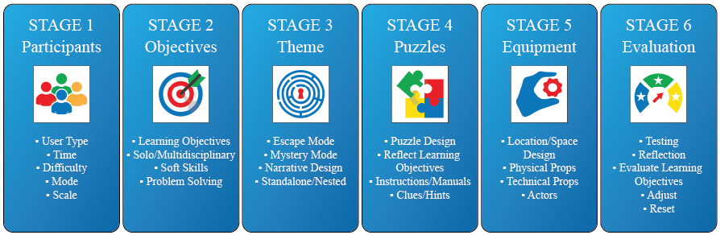
Figure 1. The escapED framework.
Aligning with stage one of the escapED framework shown in figure 1, the creation process started with discussions aimed at understanding the project’s target demographic. These discussions provided the team with insights into who the users of the escape rooms would be, allowing game designers to estimate key design elements such as the duration of play, the difficulty level of the escape rooms, the game mode, and the overall scale of each Educational Escape Room (EER). However, in a more agile approach to better suit the needs of the target audience, and evolving designs, both the estimated playtimes and difficulty levels were adjusted during subsequent later stages of development.
Following the guidelines from stage two of escapED, and in line with the project aims, a range of subjects relating to human rights were discussed to determine learning objectives. A shortlist of five topics were then selected for advancement into the development stage: racism, discrimination, disability, borders, bullying, and modern slavery. The twelve project members who had been introduced to the escapED framework, and would therefore design the games, were then separated by nationality into five teams. Each of the teams took one of the chosen subjects and was tasked with creating two escape rooms relating to them, using the framework as a basis for their designs. In total, ten escape rooms were developed. Nine of these were physical hands-on experiences whilst the final escape room, inspired by lockdown conditions in the United Kingdom, was developed to work in a virtual online space.
At Coventry University, the team, who for the most part possessed knowledge of but were themselves relatively new to the escapED framework, chose to design two EERs centered around the theme of modern slavery. These EERs were titled Fast Fashion, and Victor’s Story, the latter of which serves as a case study example within this paper.

Case Study: Victor’s Story
The primary aim of Victor’s Story was to create an interactive and immersive experience that would equip learners with essential knowledge about the causes of modern slavery and its impact upon victims, and victim’s families. To achieve this, the EER needed to foster an emotional connection between player and subject matter, encouraging participants to become advocates for the issue and spread awareness, thereby driving change among their peers. To gain an understanding of modern slavery, which is a highly complex and delicate subject, research was undertaken using resources gathered from the United Nations, the Government of the United Kingdom (UK), and recognized global non-governmental organisations (NGOs). Books, articles, and relevant journal papers were also examined. However, most importantly, witness testimony was obtained from web-based sources, in both written and video format, which provided valuable insight from the victims of modern slavery themselves. This research also added to the understanding that modern slavery does not stand as a topic alone and is heavily tied to the subject of human trafficking. With the EERs target demographic being both youth workers and young people, the decision was made to avoid the worst forms of modern slavery, such as sexual exploitation and organ harvesting. Instead focusing broadly on human trafficking and the most common form of modern slavery, forced labour, which see’s people held captive by criminal gangs and forced to work for little or no recompense often under the belief that they were paying off a debt.
Entering stage three of escapED and using the gathered research, a narrative for the escape room was created. This featured a character named Victor who, like many victims of modern slavery, had been trafficked into modern slavery using promises of a new life and affluent job prospects in the west. Upon arrival in the UK, Victor was taken to accommodation where he was held alongside a group of fellow modern slaves. This location became the setting for the escape room whilst the story of Victor’s trafficking and incarceration helped define the puzzles and gameplay that would drive it. To this effect, a set of secret diary pages, written and hidden by Victor, were created. These told the story of his kidnapping and life working as a forced labourer whilst providing small clues to the room’s other puzzles.
The escape room location was designed to be purposefully small so that when occupied by a team of five or six players they would feel cramped, awkward, and uncomfortable. To compound this, the escape room was populated with items of rubbish, such as old newspapers, empty drink bottles, cans, crisp packets, and other detritus, with the aim of making players feel slightly dirty and wary of what they touched. The addition of these items also helped to provide places where puzzle items could be hidden. Wanting to create an emotional experience, within which players could experience a suspension of disbelief, the game’s initial design attempted to avoid the traditional locked box approach often found within escape rooms. Unfortunately, this was found to be unavoidable. To alleviate this, in stage four of the methodology each of the puzzles within the room were created using items that were relevant to the location or situation, i.e. they could be found within a room where victims of modern slavery were held, or a building site where forced labourers may have worked. For example, one simple puzzle used a partly completed jigsaw puzzle with the code to open a lockbox written on the back. Another utilized a pack of playing cards with numbers written upon them and a separate cypher code that indicated which cards held the numbers relevant to opening another lockbox. One might imagine both of these items being placed into a room where people are held captive for long periods of time without anything to do. Several red herrings were also placed into the room, one of which, an old non-functional mobile phone, garnered particular attention from the players. As players progressed through the game, they would uncover diary pages that provided more information about Victor’s story as well as revealing a coded phrase that would allow them to escape the room once the diary was complete.

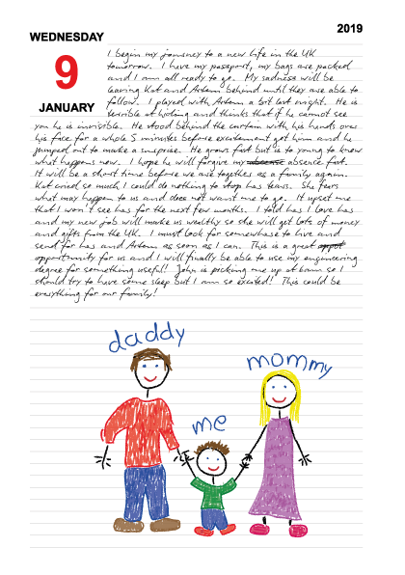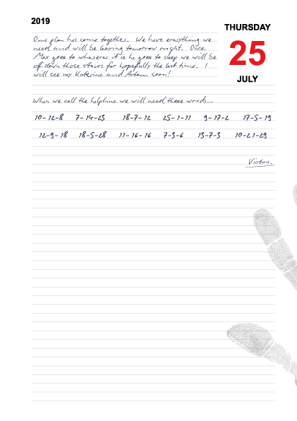
Figure 2. Sample of the Diary Pages from Victor’s Story Escape Room.
A flow chart was created to help designers gain a greater understanding of how all the games puzzles were incorporated before purchasing all the items required to play them (see figure 3). This showed the interactions between each of the individual puzzles and their components, their relationships with each other, and how they combined to form the complete escape room solution. This approach proved invaluable when ensuring that, no matter what order the puzzle items were discovered, players would always be able to progress towards the escape rooms solution rather than hitting a dead-end.
Once the escape rooms design was considered complete, the items needed to construct it were purchased and any objects that needed construction, such as a lock box with a false bottom, were built. Internal testing sessions were held amongst team members to validate the escape rooms’ functionality and using an iterative process, the issues that were discovered during the tests were resolved using small incremental changes to the game. This was an important factor for the games’ balance and allowed changes to be made without overly affecting other areas of the escape room experience. For example, during internal testing it was found that players often struggled to find a piece of paper hidden within the recording slot of an audio tape, this was rectified by simply drawing a small X onto the tape next to it in order to draw the player’s eye.

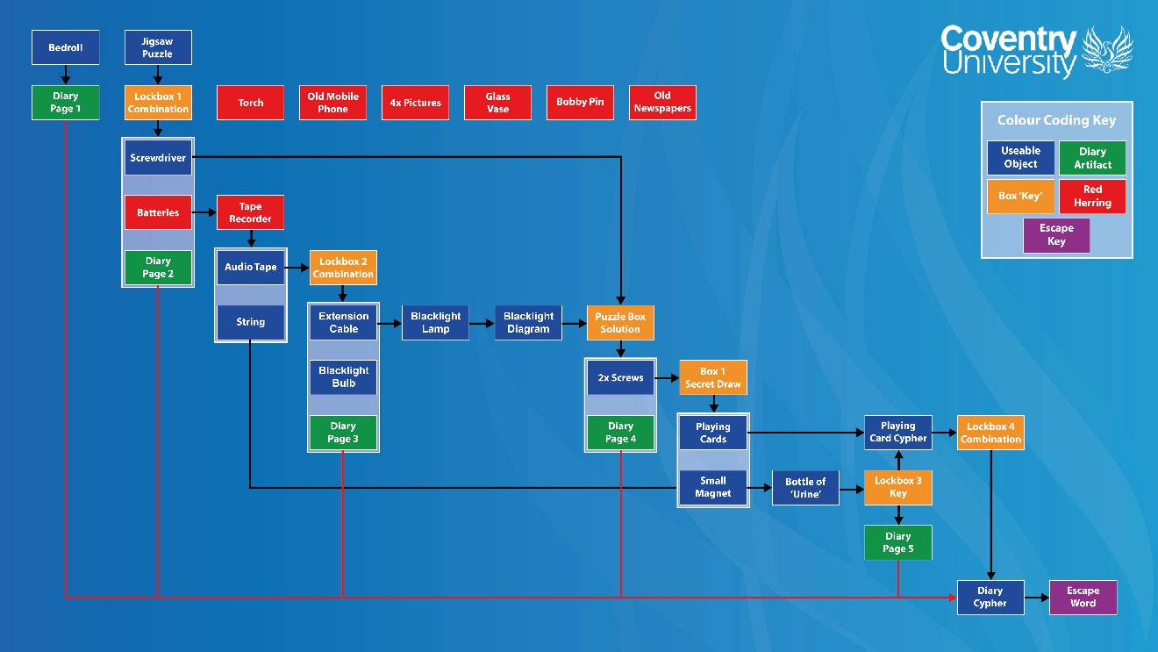
Figure 3. Flow Diagram for the Victor’s Story Escape Room.
The development of Victor’s Story, and the other escape rooms created under the banner of Escape Racism, followed the escapED framework closely. However, based on the author’s experience of developing video games, there were several deviations from some stages of the framework, particularly stage one, when creating Victor’s Story. These changes and additions made the development of the escape room a much more agile, iterative, and flowing process. With stage one (Participants) the Time limit of the escape room was roughly determined and later modified once the game had been play-tested during stage six (Evaluation). It should be noted that this modification is, however, provided for within the escapED framework. Changes were also made to how decisions were made about the game’s Difficulty, whilst an initial determination of general Difficulty were made during stage one, this was later modified during the creation of the puzzle components at stage four (Puzzles). Both the Mode and Scale of the game were determined out of sync with escapED, taking place during stage three (Theme) rather than within stage one. A new step was also added to stage one, Research, where investigation was conducted to gain a wider understanding the topics of modern slavery and human trafficking. The knowledge gained from this proved invaluable when designing the games Theme, Puzzles, and Learning Objectives whilst providing insight into the Mode that the escape room should utilize. In stage two, a seemingly logical change was instigated by moving the Problem Solving step to stage four (Puzzles), allowing puzzles and their associated solutions to be created in tandem. In stage four (Puzzles), Instructions and Manuals were created, however, these were heavily modified and finalized during stage six (Evaluation), this again being considered as an adjustment rather than a change to the framework. Finally, a new step was added to stage four, Game Flow, which allowed designers to map the escape rooms gameplay so as to understand its flow prior to purchasing the items it would consist of.

4. Methods and Material
The aim of this study is to assess the educational value of ten EERs designed for the Escape Racism project using the escapED framework. The assessment process utilized a design-based approach whereby each of the games were created and then individually tested by groups of educators, youth workers, and youths. Design-Based Research (DBR) is an iterative methodology that involves developing solutions to problems, testing them in practice, and refining them through cycles of design, implementation, and analysis in real-world settings, making it ideal for reflecting on the escape room design process using a published framework [19]. In total, n=215 participants took part across the project and the number of participants testing each game varied in size; for example, n=29 participants tested Victor’s Story, the case study presented within this paper. Use of feedback gathered from end-users is seen as a novel approach to that of collecting data from that of escape rooms designers whose feedback may contain creator-biased viewpoints. The designers of the EERs then took opportunity to reflect on feedback, analyse the data, and their own design decisions, before refining the games content in a cyclical iterative process. Designers were also able to critically assess whether the processes they had undertaken matched the escapED framework, allowing them to present findings and possible recommendations for improvement [19]. The research questions this study addresses are therefore: (1) Is the escapED framework a viable methodology for creating educational escape rooms? (2) Do educational escape rooms created using escapED provide educational benefits? (3) Can the escapED framework be adapted to reflect on the actual design process?
As stated, a total of n=29 participated in the evaluation of Victor’s Story. All players participated in a pre-game briefing, post-game debrief and completed an online questionnaire externally once the session had ended. During testing, as players arrived at the test location, they were seated outside the escape room and informed that they had been invited to uncover the events which had taken place within it. After some brief safety advice, participants were told that they had a 45-minute window within which to solve the escape room starting from the time they entered.
Upon entering the escape room, many of the participants were observed tentatively looking for clues, often picking up or moving items before discounting them and putting them down. However, after discovering their first puzzle, or a lock box, the mood changed to one of interest and excitement. Each team’s approach to solving the escape room varied, often substantially. Some teams tended to separate and wander off individually trying to figure out if items were of any value to gameplay (see figure 4). Others would announce their discoveries loudly to their teammates. However, individual participants would soon realize the power provided by working as a team and coming together to solve puzzles as a group. When teams did work together as a group from the beginning of the game, it was often the case that players took on specific roles with some players searching for items and one or two players taking charge of items that had been discovered to piece the games puzzles together. One team took an exceptionally methodical approach that saw all the participants initially search the room before placing all of their discoveries in a specific area and then coming together to examine and discuss what they had found before attempting to solve the puzzles.
The teams completed the escape room close to the forty-five-minute timeframe, indicating that this duration was near optimal for the gameplay. However, it is worth noting that some teams required assistance when they became stuck on a puzzle for more than five minutes. In such cases, the games facilitators would provide them with small hints to guide them such as “I wonder if there’s anything on the cassette tape” which helped to focus the players attention on a specific item. At no point during the game was any player told specifically how to solve a puzzle. Only a single team failed to complete the escape room within the allotted time limit.
At the end of the game, whether the players had completed the escape room or not, each team was reseated outside of the escape room to take part in a debriefing session. The one team that had not completed the escape room were asked if they wished to know the solution to the game and, having responded positively, the solution was explained to them. All of the teams were asked a series of questions including what their initial impressions of the game were, whether they felt the game was fun to play, whether it was too difficult or too easy, whether they had struggled with a particular puzzle, and what they understood from the game. To gauge whether the escape rooms learning aims had been met, teams were asked if they had learnt anything new about modern slavery and human trafficking, with each team responding positively that they had. Facilitators then provided the players with some additional facts about modern slavery and human trafficking before opening the floor to questions. At this point it was often noted that the participants’ prior knowledge of these subjects had been extremely low and was therefore dramatically improved post-game. Many of the players’ attitudes towards the subject had also been changed, with several asking questions or making remarks that showed remarkable empathy, and in some instances shock, at what they had learned.

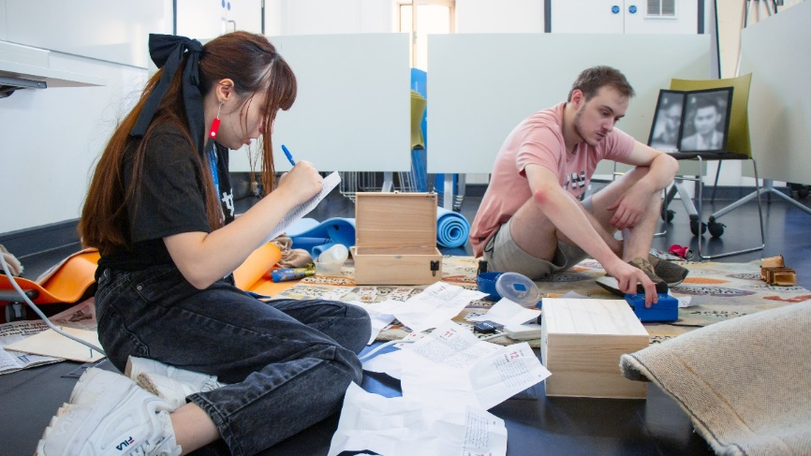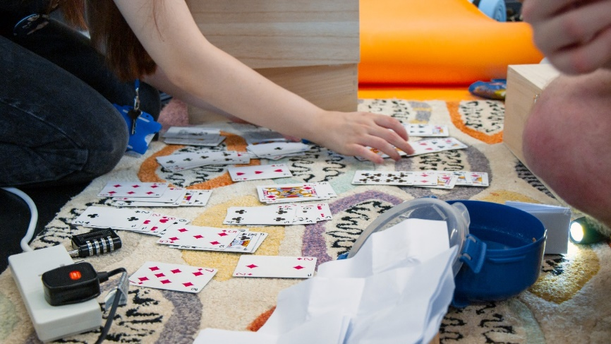
Figure 4. Testing Victor’s Story During an Evaluation Session.
To close the session, each of the participants were asked to complete an anonymous online questionnaire using the JISC online survey tool. This consisted of seventeen questions; twelve of these used a mixed Likert scale chosen to provide information about the participants previous knowledge of escape rooms in general, their experiences playing the subject escape room, how well the escape room was facilitated, and the participants willingness to engage with or promote the Escape Racism toolkit. Five questions were open-ended, allowing participants to express their opinions freely. Critically, this allowed participants to answer questions away from the escape room environment where they might have felt pressured to supply positive answers by the presence of facilitators. The responses received for questions one to twelve were then transferred to Microsoft Excel for quantitative analysis whilst a more qualitative approach was undertaken to gain understanding of responses to questions thirteen to seventeen.
Players (n=215) participated in the testing of 10 different escape rooms created for the project using the escapED framework. Each of these tests took the same format with players introduced to the game using a pre-session briefing before playing. After the session was complete, each team of players took part in a de-briefing session where they were supplied with additional information and given the opportunity to ask questions. Finally, each of the players were individually asked to complete an online questionnaire.
Descriptive analysis was carried out on the Likert-scale responses received from participants for questions 1 to 12, which included the calculation of mean averages and standard deviations, presented as charts, whilst a qualitative approach using thematic analysis was undertaken to gain understanding of responses to questions 13 to 17. This allowed us to create themes or categories of participants’ experiences of using escape rooms for learning about modern slavery and the other topics covered within the project. After testing across ten different escape rooms, created within the Escape Racism project and using the escapED framework or an adaptation of it, the following results were obtained from a post-session survey. Tables one to four show responses to questions one through twelve, each of which used a mixed Likert scale. This research was approved by Coventry University Ethical Approval process.

Results
The following results show data gathered from n=215 participants during testing of ten different escape rooms created for the Escape Racism project using the escapED framework. Table 1 shows data for player escape room experience. The responses to questions one (Q1) showed that whilst more than half (61.86%) of the participants had experienced playing an escape room prior to testing, less than a third (27.69%) stated they had played a virtual escape room when answering question two (Q2). This indicates that whilst escape rooms are rapidly becoming a mainstream form of entertainment, they may be under exploited in a virtual or augmented reality space, raising the possibility that these forms of escape room could be easily further exploited. Question three (Q3) asked whether players had completed their specific escape room within the allotted playing time. Two-thirds (68.69%) of the players indicated that they had done so, showing that, in general, when combined, the level of difficulty (see question six) versus expected playing time was close to optimal across the range of generated escape rooms.

Table. 1. Questionnaire responses to Questions 1, 2 (Escape Room Experience) & 3 (Escape Room Completion).
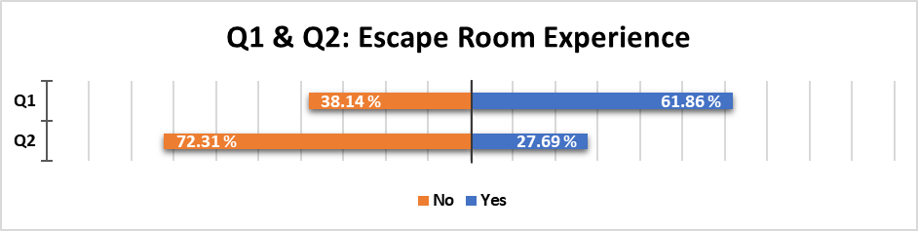
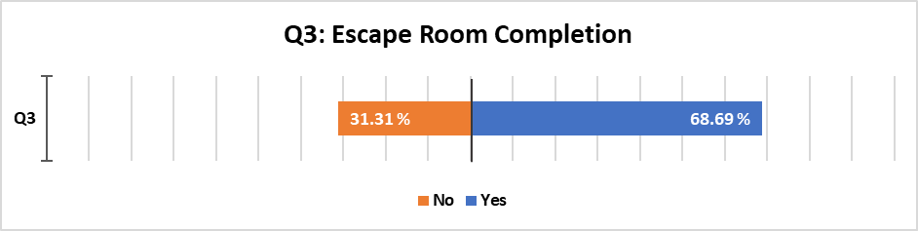

The next three questions, shown in table 2, focused on the player’s experience of the escape rooms. When asked to score the enjoyment level experienced when playing the escape rooms, question four (Q4), nearly all the participants (97.67%) scored the games six or above out of ten. This indicates that the creators of the escape rooms were highly successful in generating engaging experiences which players could lose themselves in, possibly entering a state of flow. Question five (Q5) asked how the escape rooms had performed as learning experiences, 90.67% of participants rated them as six or more, showing that, despite some anomalies, most participants felt that they had learnt something new about the subjects covered. This correlates well with the interest that was often observed within the post-session debriefs. In response to question six (Q6), which related to the difficulty levels encountered within the escape rooms, 30.23% of participants thought that the games were too hard, scoring difficulty an eight or above out of ten. A further 11.16% of participants scored the difficulty of the escape rooms at a three or below. However, most players (58.60%) scored the escape rooms difficulty within the middle range of four to seven, showing that the overall difficulty experienced across the games was more likely correct.

Table 2. Questionnaire responses to Questions 4 (Level of Enjoyment), 5 (Quality of Learning Experience) and 6 (Difficulty Level).

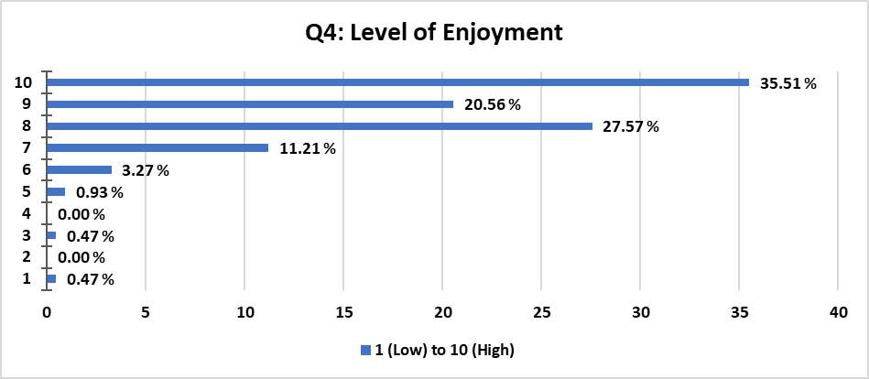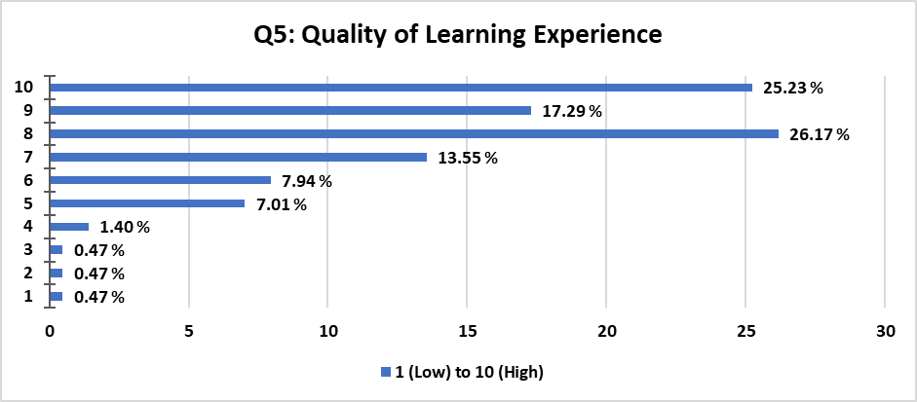
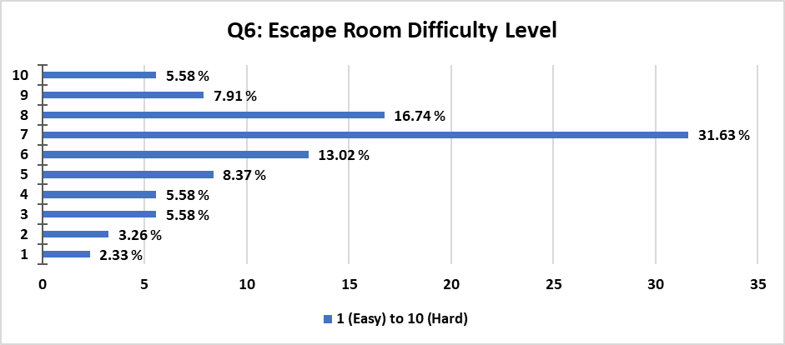
Table 3 covers questions seven, eight, and nine which concentrate on understanding how the various escape rooms had been facilitated. When asked in question seven (Q7) how good the information provided to participants prior to playing the rooms was, 86.97% of participants stated the information was good or very good compared to 12.55% who thought it was average and just 0.46% who thought it was poor. Question eight (Q8) provided data about in-game facilitation with 92.52% feeling that it had been good or very good, 6.54% average and 0.93% poor. The final question on facilitation (Q9) reflected upon the post-game debrief and the explanations provided about the games. Here 93.02% of participants felt that facilitators had done a good or very good job, 6.04% an average job, and 0.93% felt that the facilitators had done badly. It should be noted that none of the participants stated that the facilitation had been very poor at any stage of the tests. These figures also strongly indicate that the facilitation of the testing sessions, which consisted of a brief introduction, light guidance during gameplay, and a post-session debrief were well perceived by the participants.

Table 3. Questionnaire responses to Questions 7(Information Provided Prior to the Session), 8 (Facilitation During Gameplay) and 9 (Information Provided After the Session).
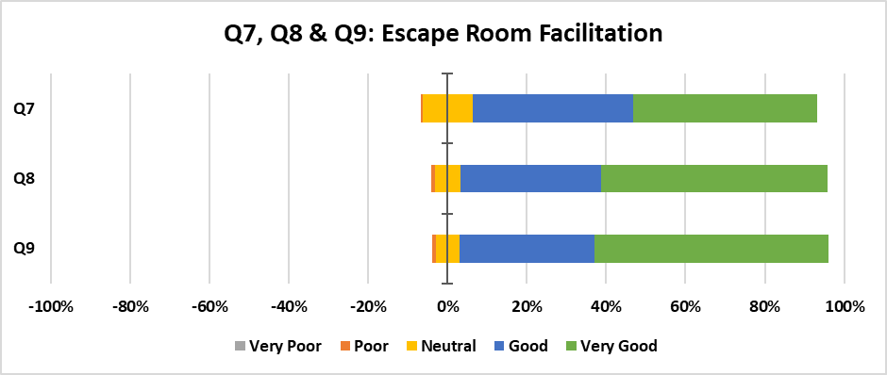

Participants were also asked a series of questions that related to the wider project context and its aim of providing a toolset that could be freely utilized by anyone. These are shown in table four which covers questions ten, eleven and twelve. Data from responses to question ten, which asked whether players would recommend escape rooms created within the project to their friends and colleagues, indicate that 84.65% of participants would recommend the escape rooms. This figure increased slightly when participants were asked whether they would be willing to play other escape rooms related to Escape Racism (Q11). This was deemed a highly positive response to the projects outputs and supplied confirmation that the players had enjoyed and engaged well with the escape rooms, to the point where they were willing to encourage their friends and colleagues to play. However, in terms of whether participants would consider using an online location that offered free instructions and guidance for building and running educational escape rooms (Q12), whilst almost half of the participants (49.76%) stated that they would take advantage of such an opportunity 44.65% only stated that they might, with 5.58% saying that they would definitely not. These latter responses cannot be properly explained but perhaps indicate an unwillingness amongst some participants to create and run escape rooms even when the information to do so is freely given on how to do so. Cost may also be an unaccounted factor here.

Table 4. Questionnaire responses to Questions 10 (Would You Recommend the Escape Room to Friends & Colleagues), 11 (Would You Play Other Educational Escape Rooms), and 12 (Would You Use an Online Location Providing Free Educational Escape Room Experiences).
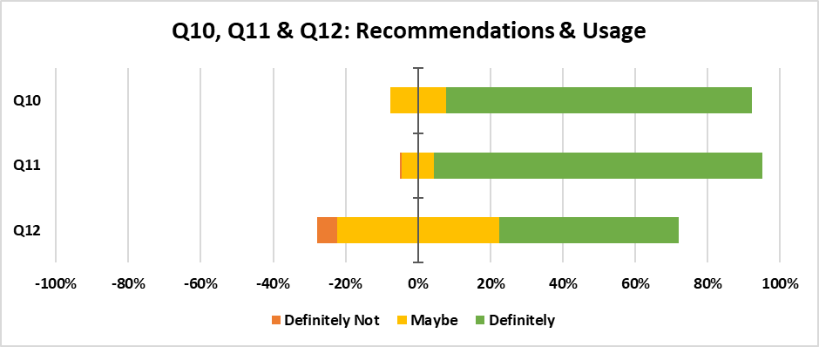

An additional five qualitative questions were also asked. These sought to gain insight relating to the escape rooms puzzles, knowledge enhancement, and game quality. Once these were received, they were utilized by the designers of each game to make subtle changes to each escape room in order to improve them using a design-based methodology. Whilst over 900 responses to the five qualitative questions were received from our 215 participants across each of the partner languages, only the responses provided in the English language and applying to the Victor’s Story case study, of which there were 76, are examined here.
Question thirteen (Q13) asked participants to indicate which of each escape rooms puzzle they had found the easiest to solve. The answers to this question were varied, however, one puzzle stood out within Victor’s Story in multiple responses involved a key submersed in a vase filled with ‘urine’, a vitamin tablet dissolved in tap water. Participants were required to combine a magnet with a piece of string, both of which could be found in lock boxes, to fish a key out of the vase. This puzzle was modified in a simple manner, by filling the base of the vase with bobby pins and therefore making it more difficult to initially see and then extract the key.
In question 14 (Q14), participants were asked which puzzle they found the most difficult to solve. In the case of Victor’s Story responses overwhelmingly indicated that the overarching puzzle, which allowed players to escape the room, was the most difficult to solve. The puzzle required participants to discover Victor’s final diary entry. The content of this page included a series of numbers which indicated a date, which in turn indicated another of the diary pages, a line of text upon the relevant page, and finally a letter within that line. By resolving the code participants could determine a password which was required to exit the room. The puzzle was made easier by simply circling the first of these indicated letters upon the relevant diary page, connecting the two aspects together and providing insight to the players. Interestingly, taking the prevalent answers to these two questions we could conclude that players found object-based puzzles, where items needed to be combined and utilized together, easier to solve than purely cognitive puzzles that required logical thought in order to solve them.
The responses to questions fifteen (Q15) provided insight into possibly the most important reason for creating an educational escape room. This simply asked whether the escape rooms had provided participants with new knowledge of which they had been previously unaware, in other words, had playing the escape room educated them. The responses to this question were overwhelmingly positive, and in the case of Victor’s Story, reiterated that the escape room had generated an emotional attachment to the subject of modern slavery. This had also been made obvious during the post-session debriefings. For example, one participant stated “I learnt a lot about the huge issue of modern slavery. I found it very thought provoking and informative, especially the backstory behind it,” whilst another said that “Learning that there are enough modern slaves to match the population of Australia was something new and haunting,” both of which appear to display evidence of learning and emotion. To further investigate this, participant responses have been qualitatively assessed with four distinct categories emerging: (1) Increased Awareness / Knowledge, (2) Emotional Response, (3) Both, and (4) Neither (see Table 5).

Table 5. Knowledge of Modern Slavery
Category | Sample Quotation(s) | Frequency
Increased Awareness / Knowledge | “I didn't know that the population of Australia was the same as the amount of people in slave labour.”  “The lengths people have to go to before they can receive aid when it comes to being held against their will with no form of communication.”  “Yes, and I feel I know a lot more about forced labour, how it happens, and how prevalent it actually is.” | 21
Emotional Response | “Pretty shocking to hear about how many people were in modern slavery.”  “Learning that there are enough modern slaves to match the population of Australia was something new and haunting.” | 3
Both | “Yes, I learnt a lot about the huge issues of modern slavery. I found it very thought provoking and informative, especially the backstory.”  “I have a greater understanding of the issues pertaining to modern slavery, as well as a greater empathy with the experiences of those involved.” | 3
Neither | “Not really although it is important to bring awareness to the topic.”  “Not enough. I was already aware of modern slavery and did not learn much integrated into the activity. The debrief contained more.” | 2

Question sixteen (Q16) asked participants to detail aspects of the games that they thought could be improved. Many varied responses were received, some of which were contrary to each other, for example, using the Victor’s Story case study, one participant stated, “if possible, have a smaller room” whereas another requested “maybe more space.” However, no response stood out as being critically important beyond calls to make the diary puzzle easier to resolve.
The final question, question seventeen (Q17), asked participants to provide any additional comments about their escape room experience. In total, only nine responses were received in the English language and these again related to Victor’s Story. Two participants used this section to offer advice on how the escape room could be improved, with one stating that “I think sometimes the focus was more on the puzzle solving than the actual content/learning and that did get a bit lost, particularly with some of the harder puzzles.” Another two noted the pedagogical strengths of the escape room paradigm, with one commenting that “It was rewarding to understand the concept of conveying awareness through playing.” The remaining five comments indicated that the respondents had found the escape room an enjoyable and immersive experience, with one writing that “It was a great escape room and I got really into it and felt immersed as soon as we got closed in”, whilst another simply stated that it “Was really fun!”.

Discussion & Conclusions
Within this paper, we have attempted to assess the viability of using the escapED methodology to inform the design of ten educational escape rooms and determine whether the expected educational outcomes were achieved. The opportunity to do this was provided through Escape Racism, a project that aimed to create and utilize several educational escape rooms facilitating social change amongst young people. Members of the Escape Racism team were initially introduced to the framework through documentation and a follow-up seminar that enhanced understanding of how to employ the framework when creating EER’s. Team members were then split into five groups, tasked with creating two escape rooms each, and provided with assistance in using the framework when required. In total, ten EER’s were generated. These were tested by n=215 non-project-affiliated participants to gauge their functionality and educational value. During testing, using a design-based approach, modifications were applied to improve the escape rooms, where deemed necessary and, once they were considered fully functional, manuals and instructions were created for each. These were placed online and made freely available for anyone to use either in their original form, or in a modified format.
To determine how successful the use of the escapED framework had been, and therefore answer our first research question, the decision was taken to assess the generated educational escape rooms, not through the eyes of those who had created them, but rather those who would eventually play them. Using this approach, the evaluation would avoid collecting data that may have been biased by the viewpoints of the escape rooms creators, who could be easily blinded by any failings in their own creations. The opinions provided by the end-users would in this way either prove or disprove the quality of the escape rooms created, how well they had been constructed, and therefore the framework itself.
The combined data from all ten escape rooms show that the utilisation of escapED was successful. Mirroring the findings of Kazinidis et al (2020), the enjoyment level of participants who played the escape rooms was noted to be high. This was evidenced both during testing and within the post-escape room debriefings within which players evoked a sense of joy and wonder at the experience. Whilst a pre-test questionnaire was not utilized to gauge players’ understanding of topics prior to the testing sessions, enhanced learning was noted. The strongest indication for this can be found within the participants written and verbal communications provided post-test. Here, 68.69% of players rated the learning experience eight or above on a ten-point Likert scale, whilst 90.67% judged the learning experience to be above average. Furthermore, responses within the online questionnaire showed that knowledge and awareness of the subjects did not just cover one theme but rather a broad range of knowledge about the subjects. For example, about modern slavery, some participants remembered key facts about the subject whilst others focused on information relating to how people find themselves within modern slavery or the difficulties they encounter when attempting to escape from it. This shows that, in relation to our second research question, the escape rooms created using escapED did indeed provide educational benefits.
It should be noted that the escapED framework was not employed by following its structure to the letter. In the case study at least, and throughout the project partners, the process was moderately adapted to make it more agile and iterative at several stages. This appears to have enhanced its effectiveness whilst meeting the needs of the escape room designers. In some cases, this was due to project requirements whilst in others changes were made positioning decisions and determinations at junctures which seemed to create a more logical flow to the game design. This shows that, in relation to our third research question, the escapED framework can be adapted quite easily to enhance its effectiveness for bespoke interventions.
To list the changes made when creating our case study, Victor’s Story, in stage one, rather than determine the Time that it would take to play each escape room at such an early stage of development, a placeholder estimation of the time required was put in place and then adapted during the Evaluation stage. This allowed for more informed decisions about the length of time it would take to complete each room and balance them. An initial determination of each escape rooms Difficulty was also undertaken within stage one; however, Difficulty was adapted at both stage four and six as the puzzles contained within the escape rooms were created and evaluated. Additionally, both the Mode of the escape rooms and their Scale were determined during stage three once the games’ themes had been decided upon. Effectively, this meant that whilst several initial decisions were made during stage one of the escapED framework, only the user type was fully determined at this stage with the finalization of other factors left until later in development when the escape rooms were less ephemeral. However, a new step, Research, was added to stage one. This was imperative if the designers were to fully understand the intended content for the escape rooms and proved invaluable when developing their Theme. However, depending upon the creator’s prior knowledge of the intended subject matter, this stage may not be applicable in every case.
In stage two, the escapED framework advises that designers develop Problem Solving challenges, this seems somewhat pre-emptive as the logical point to do this would normally be as the game’s puzzles are being developed. Problem solving was therefore moved and incorporated into stage four alongside the creation of Puzzles.
Instructions and Manuals for each escape room were created during stage four, as per the escapED framework. However, due to the iterative and ever-changing nature of the design process, these were adapted and finalized within stage six. Another new step was also added to stage four, Game Flow. This involved the creation of a flow diagram showing each of the escape room’s components and detailing how they connected to, and interacted, with each other. This allowed the EER’s creators to view and adjust the paths that players could take from their initial entry into the rooms through to the room’s solution, ensuring that the players would never encounter a dead end where they were unable to progress and complete the game. Based on the findings from development of the EER’s, a modified version of the escapED framework, as used withing the Escape Racism project can be viewed in Figure 5 which shows steps that were iterated upon within later stages (*), steps that were moved from their original stage (**), and new steps which were added (***), as described above.

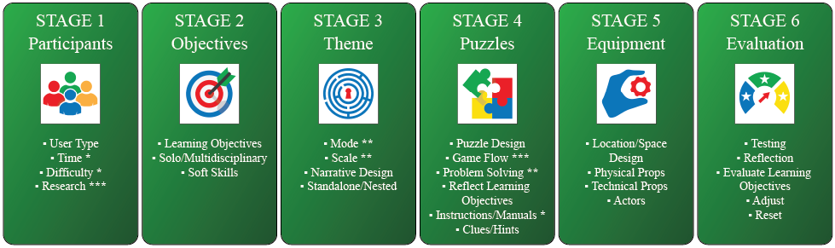
Figure 5. The modified version of the escapED framework used to create Victor’s Story (* Iterated within later stages, ** Moved from original stage, *** New step).
The testing sessions which were held were of critical importance to the creation of enjoyable, functional, and educational escape room experiences. The sessions allowed designers to adapt and modify their creations using a design-based approach, taking feedback on-board then making small incremental changes as and when issues were discovered. Once issues were thought to be fixed, the games could then be retested in the following sessions in a rapid iterative process. Whilst the testing sessions were critical, the follow-up debriefings that were conducted post-test were invaluable. These provided insight into the player’s immediate thoughts about the escape rooms and generated some interesting conversations about their subject matter that would not normally be available if a standalone questionnaire had been employed. However, in hindsight it would have been of great benefit to have obtained an overview of player knowledge prior to the testing sessions. A post-test comparison could then have been made to measure any increase in knowledge in a more scientific approach. It would be beneficial to test and analyse participants’ memory of the escape room’s themes, and the retention of the knowledge provided when playing them, after some period of time has passed. In doing so, the longevity of knowledge retention could be gauged, strengthening the case for or against the use of escape rooms within education.
The escape rooms also seem to have generated an emotional response among some participants. This was often witnessed during the post-test debriefings where players were seen to be visibly moved by their experiences. Answers provided through the questionnaire also evidence this with one participant going so far as to say the knowledge they had gained was “new and shocking”.
This paper presented the development, evaluation, and deployment of ten escape rooms which were created by a multi-national team of developers. Whilst some adaptations were made to the escapED framework during the development process, we believe that this is within the spirit of the framework’s creators. It should not be considered as a rigid structure but rather one that provides a fundamental framework for the creation process that can be adapted and modified in an agile manner wherever necessary to suit the requirements of the user. This in turn aligns with the functionality of the framework, as shown by the successful creation and use of ten educational escape rooms created using it. The framework will guide users towards the design and development of highly functional educational escape rooms.
Whilst the outcomes of assessing the EERs created using the escapED framework are beneficial for the educational community, more development and testing of the framework is required, if it is to cater to a wider range of escape room formats. For example, a version of the framework which is applicable to the escape-room-in-a-box format is desirable. This format, being much cheaper in cost than traditional full-scale escape rooms, could be a valuable tool for educators who have limited funding.

Acknowledgments
The Escape Racism project was co-funded by the Erasmus+ Programme of the European Union, project number 2019-2-ITO3-KA205-016906.

Conflict of Interest
The Authors declare that there is no conflict of interest.

Research Involving Human Participants
These studies have been approved by Coventry University ethics committee and have been performed in accordance with the ethical standards as laid down in the 1964 Declaration of Helsinki and its later amendments or comparable ethical standards.

References
[1] S. Nicholson, "Peeking behind the locked door: A survey of escape room facilities'. White Paper available at https://scottnicholson.com/pubs/erfacwhite.pdf, 2015.
[2] E. Kroski, "Escape Rooms and other immersive experiences in the library", Chicago: ALA Editions.
[3] The Logic Escapes Me, "International Escape Room Markets Analysis", https://thelogicescapesme.com/news/international-escape-room-markets-analysis/. 2019. Retrieved 14-06-2024.
[4] A. Veldkamp, J. Daemen, S. Teekens, S. Koelewijn, M.P.J. Knippels, W.R. van Joolingen, "Escape boxes: Bringing escape room experience into the classroom", in British Journal of Educational Technology, vol.51, no.4, pp1220-1239, 2020. https://doi.org/10.1111/bjet.12935
[5] S. Clarke, J. Daryl, S. Arnab, Morini, L, H. Keegan, & O. Wood, "escapED: A Framework for Creating Educational Escape Rooms and Interactive Games for Higher/Further Education", in International Journal of Serious Games, vol.4, no.3, pp. 73-86, 2017. https://doi.org/10.17083/ijsg.v4i3.180
[6] G. Guigon, J. Humeau, & M. Vermeulen, "A Model to Design Learning Escape Games: SEGAM", in 10th International Conference on Computer Supported Education, Madeira, Portugal, pp 191-197, 2018. https://doi.org/10.5220/0006665501910197
[7] L. Botturi and M. Babazadeh, "Designing educational escape rooms: validating the Star Model", in International Journal of Serious Games, vol.7, no.3, pp. 41-57, 2020. https://doi.org/10.17083/ijsg.v7i3.367
[8] P. Fotaris and T. Mastoras, "Escape rooms for learning: A systematic review", in Proceedings of the 13th European Conference on Game‐Based Learning (ECGBL), pp 235-243, 2019. https://doi.org/10.34190/GBL.19.179
[9] I. Kazianidis, G. Vasilios, P. Fotaris, & A. Tsinakos, "Educational Escape Room for Disaster Preparedness and Response Training", in Proceedings of the 14th European Conference on Game‐Based Learning (ECGBL), pp 832-839, 2020. https://doi.org/10.34190/GBL.20.093
[10] M. Csikszentmihalyi, "Flow and the foundations of positive psychology: The collected works of Mihaly Csikszentmihalyi". Berlin: Springer, 2014. https://doi.org/10.1007/978-94-017-9088-8
[11] P. Fotaris & T. Mastoras, "Room2Educ8: A Conceptual Framework for Designing Educational Escape Rooms", in Proceedings of the 16th European Conference on Games Based Learning (ECGBL), pp693-701, 2022. https://doi.org/10.3390/educsci12110768
[12] S. Arnab & S. Clarke, "Towards a trans-disciplinary methodology for a game-based intervention development process", in British Journal of Educational Technology, vol.48, 2016. https://doi.org/10.1111/bjet.12377
[13] K.L. Neumann, F. Alvarado-Albertorio & A. Ramirex-Salgado, "Online approaches for implementing a digital escape room with preservice teachers", in Journal of Technology and Teacher Education, Vol 28, No. 2, pp 415-424, 2020, Society for Information Technology & Teacher Education, Waynesville, NC USA. ISSN 1059-7069. https://www.learntechlib.org/primary/p/216209/
[14] E. Löffler, B. Schneider, T. Zanwar & P.M. Asprion, "Cysecescape 2.0 - a virtual escape room to raise cybersecurity awareness", in International Journal of Serious Games, Vol. 8, No. 1, pp 59-70, 2021. https://doi.org/10.17083/ijsg.v8i1.413
[15] R.A. Martina & S. Göksen, "Developing educational escape rooms for experiential entrepreneurship education", in Entrepreneurship Education and Pedagogy, Vol. 5, No. 3, pp 449-471, 2022. https://doi.org/10.1177/2515127420969957
[16] H. Eukel & B. Morrell, "Ensuring educational escape-room success: the process of designing, piloting, evaluating, redesigning, and re-evaluating educational escape rooms", in Simulation & Gaming, Vol. 52, No. 1, pp 18-23, 2021. https://doi.org/10.1177/1046878120953453
[17] J.M. Dittman, M. Amendola, R. Ramraj, S. Haynes, & P. Lange, "The COMET framework: A novel approach to design an escape room workshop for interprofessional objectives", in Journal of Interprofessional Care, Vol 36, no.1, pp161-164, 2022. https://doi.org/10.1080/13561820.2020.1870442
[18] M. Vermeulen, G. Guigon, N. Mandran & J.M. Labat, "Teachers at the heart of the learning games design: the DISC model", in 17th IEEE International Conference on Advanced Learning Technologies (ICALT 2017), 2017; Timisoara, Romania. https://doi.org/10.1109/ICALT.2017.41
[19] S. Barab & K. Squire, “Design-Based Research: Putting a Stake in the Ground”, in The Journal of the Learning Sciences, 13(1), 1-14, 2004. https://doi.org/10.1207/s15327809jls1301_1
[20] C. Hoadley & F.C. Campos, “Design-based research: What it is and why it matters to studying online learning”, in Educational Psychologist, 57(3), pp207–220, 2020. https://doi.org/10.1080/00461520.2022.2079128

